lsRequirements:

* // “python” commands should direct to python3 (can be accomplished by adding an alias in “.bashrc” file).
* // python version needs to be 3.5+.



* // “pip” commands should use pip3. 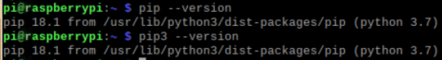
* // Use a virtual environment is preferable:
  + *python -m pip install virtualenv*
  + // From my working folder (Projects/Python/greenhouse-tflite)
  + *python -m venv gh-tflite-env*
  + *source gh-tflite-env/bin/activate*
  + // install specific libraries
  + *sudo apt -y install libjpeg-dev libtiff5-dev libjasper-dev libpng12-dev libavcodec-dev libavformat-dev libswscale-dev libv4l-dev libxvidcore-dev libx264-dev*
  + // OpenCV and TensorFlow Lite backend
  + *sudo apt -y install qt4-dev-tools libatlas-base-dev libhdf5-103*
  + *python -m pip install opencv-contrib-python==4.1.0.25*
* // We need a tensorflow lite version that works with our specific processor
  + // You can figure out your processor
  + *uname -a*
  + *uname -m* 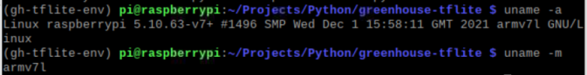
  + // Raspberry Pi 3B+ has an armv7l which is a 32-bit processor.
  + // The standard wheel install for pip will work with armv7l …
  + //… or you can pick a specific distro of tflite.
  + // The distro this will likely install is the following…
  + *python3 -m pip install tflite-runtime*
* Congratulations!!! You’re ready to run tflite models like our mold detection model.